JAVASCRIPT NOTES (1)
1. JavaScript Setup ka Mindset
Video me sabse pehle ye bataya gaya hai ki hume thoda mind ka setup change karna padega. JavaScript ab sirf browser (Google Chrome, Firefox) tak limited nahi hai. Pehle kya hota tha ki hume JS run karne ke liye ek HTML file banani padti thi, fir use browser me kholna padta tha. Par ab hum JS ko apne system (Local Machine) par direct run kar sakte hain, bilkul Python ya C++ ki tarah.2. .js File vs .txt File (The Secret)
Ye bahut interesting part hai. Hitesh sir ne bataya ki ek simple .txt file aur ek .js file me technical level par koi bahut bada fark nahi hota. Dono me text hi likha hota hai.
- Fark kya hai? Fark hai "Environment" ka.
- Jab hum .js extension dete hain, toh hum computer ko bata rahe hote hain ki is file ke andar ka text "Source Code" hai jise JS ka engine (jaise Node.js) samajh sakta hai.
- Agar tum .txt file me console.log("Hello") likhoge aur use Node.js me run karne ki koshish karoge, toh wo confuse ho jayega kyunki usne sirf .js files ko handle karne ka instruction liya hai.

3. Node.js Kya Hai? (The Engine)
JS pehle sirf browser ke andar band thi. Fir developers ne browser se wo software (engine) nikala aur use system ke liye banaya, jise hum Node.js kehte hain.
- Download: nodejs.org se ise download karna hai.
- LTS vs Current: Video me Hitesh sir ne "Current" version install kiya hai kyunki hum seekh rahe hain aur naye features chahiye. Par agar koi bade project (Production) par kaam kar raha hai toh wo "LTS" (Long Term Support) leta hai.
- Alternative: Deno JS bhi ek option hai (jo Node.js ke founder ne hi banaya hai).

4. Code Editor (VS Code)
Code likhne ke liye Visual Studio Code (VS Code) best choice hai.
- Kyun? Kyun ki isme "Color Coding," "Auto-Indentation," aur "Intellisense" (apne aap code suggest karna) milta hai.
- Tip: Hitesh sir ne kaha hai ki NotePad ya WordPad bilkul use mat karna, wo development ke liye nahi hain.
# BROWSER IS THE COMPILER FOR JAVASCRIPT??
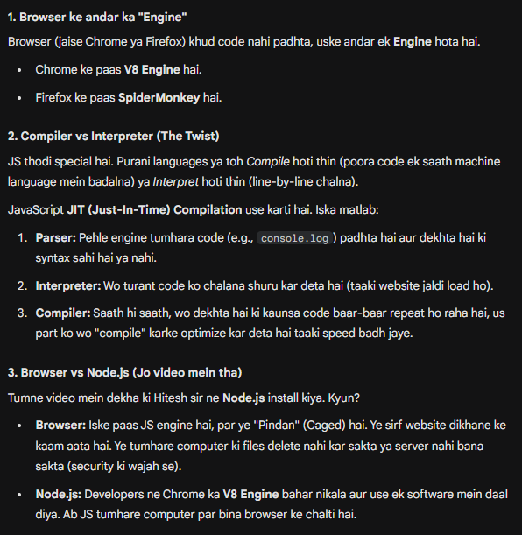
5. Code Kaise Run Karein? (Step-by-Step Example)
Video me jo code aur process dikhaya gaya hai, wo ye hai:
- Folder Banao: Apne desktop par ek folder banaya (e.g., js-hindi).
- VS Code me Open Karo: Folder ko VS Code me drag and drop kar do.
- File Create Karo: Ek file banayi test.js.
- Code Likho:
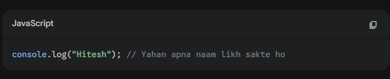
- Terminal Open Karo: View > Terminal me jao.
- Check Installation: Pehle check karo Node install hua ya nahi: node -v (Ye version number dikhayega).
- Run Code: File ko run karne ke liye terminal me ye command likho: node test.js Output: Hitesh

# IMPORTANT
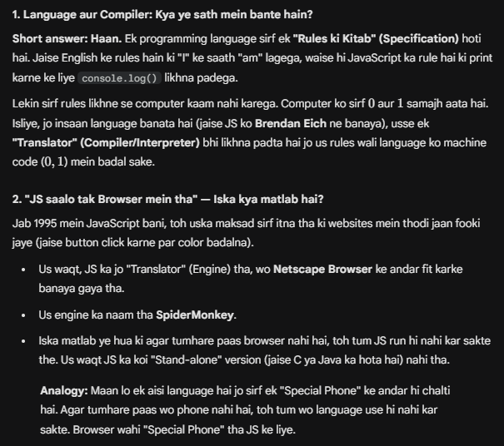

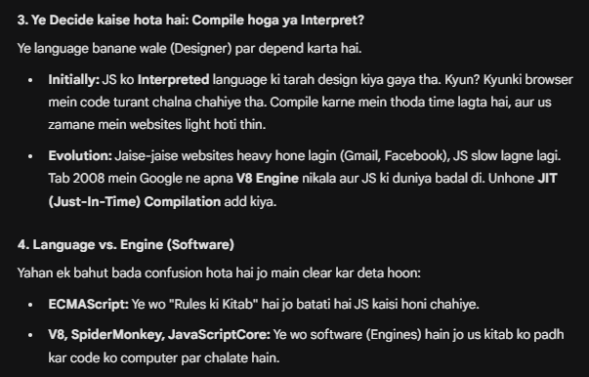6. Extra Knowledge (Under the Hood)
- V8 Engine: Google Chrome ke andar ek engine hota hai "V8" jo JS code ko machine code me convert karta hai. Node.js isi V8 engine par based hai.
- Syntax Structure: JS engine file ke andar console, ., log jaise keywords ko pehchanta hai. Agar tum spelling galat karoge (e.g., consol), toh engine error de dega kyunki uska "Parser" use nahi samajh payega.
Summary Checklist tumhare liye:
- Node.js install kar lo.
- VS Code install kar lo.
- Ek .js file banao.
- console.log("Apna Naam"); likho.
- Terminal me node filename.js karke run karo.

